COMP8430: Advanced Computer Vision and Action
Major Project Phase 3: Deployment and monitoring
Fine-Tuning and Evaluation for Robot-Based Fruit Classification
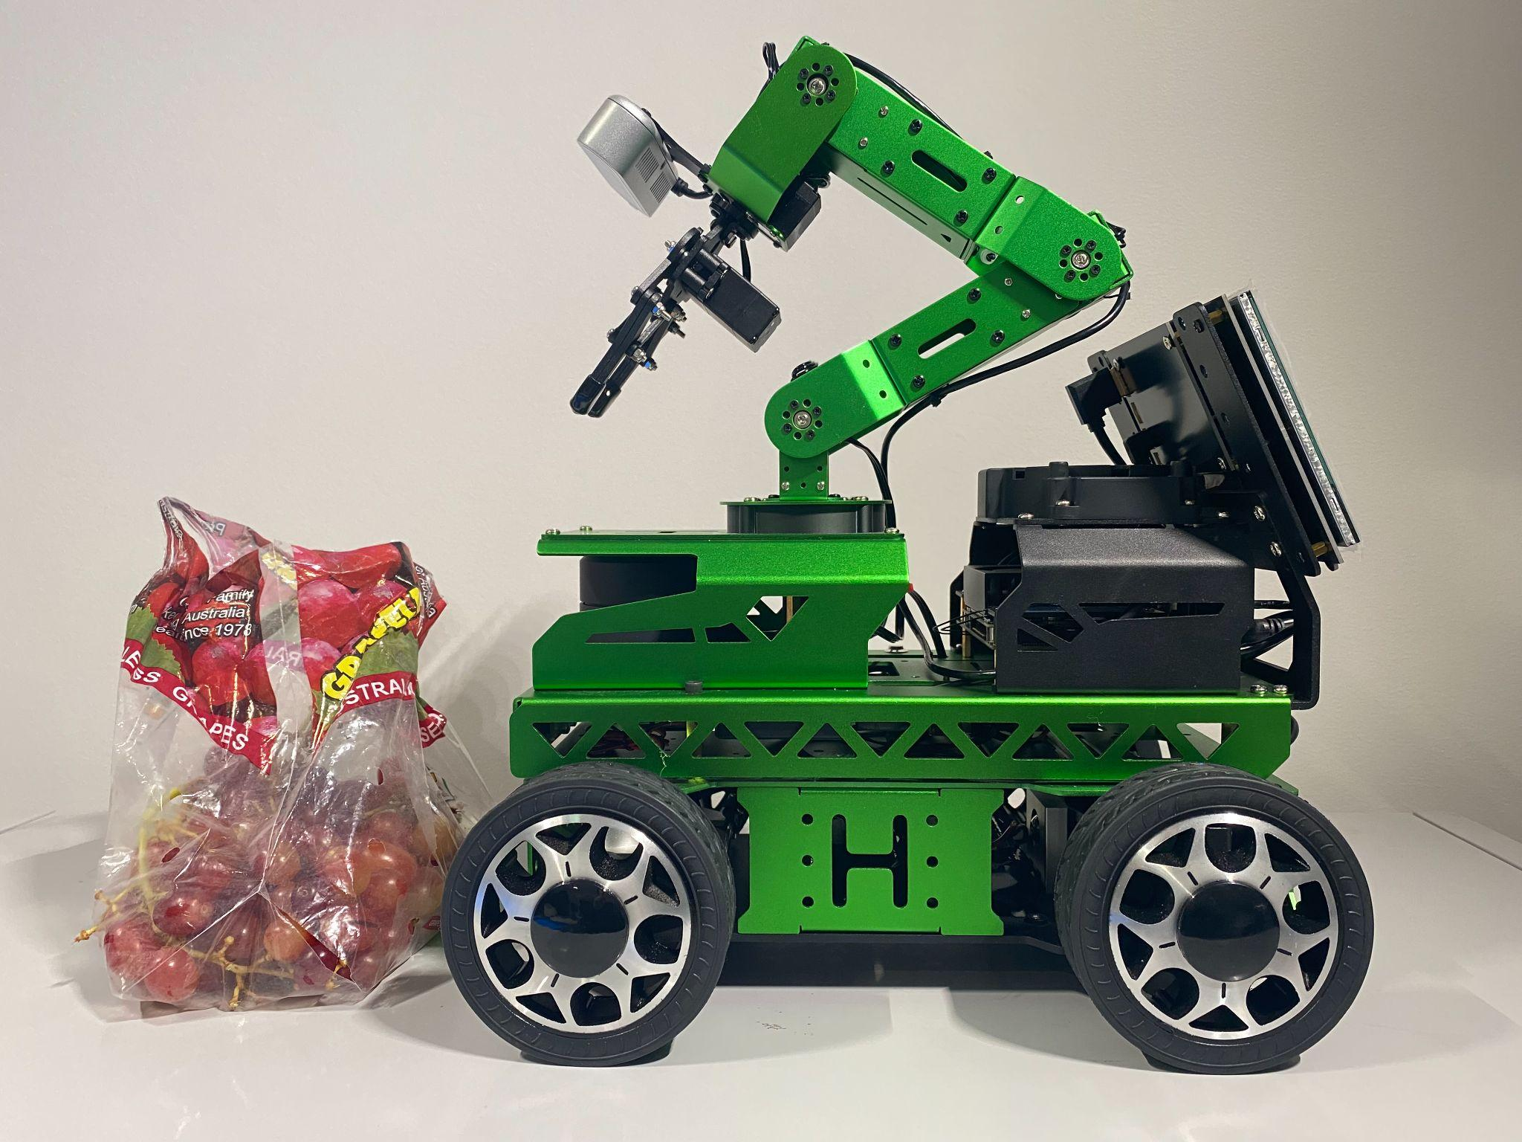
MEMBERS OF GROUP 3:
# | Student Name | Student ID
1 | Phuong Thao (Jasmine) Huynh | 46248722
2 | Prakhar Mishra | 48081906
3 | Taha Naveed Shibli | 47892641
4 | Gary Tze Hay Lau | 45245673

Table of Contents
1. INTRODUCTION | 2
2. GROUP DATASET OVERVIEW AND 3 CLASSES SELECTION  2.1 Group Dataset Summary (21 Classes)  2.2 Class Selection for Robot Deployment (3 Classes) | 2-7
3. IMAGE CAPTURE USING ROBOT HARDWARE  3.1 Hardware Setup and Image Capture Details  3.2 Visualisation of Raw Robot-Captured Images  3.3 Dataset Partitioning Strategy (Robot Images) | 7-11
4. MODEL SELECTION AND FINE-TUNING  4.1 Classifier Choice and Rationale  4.2 Fine-Tuning on Phase 2 Data (All Classes, All Members Dataset)  4.3 Fine-Tuning on Phase 3 Robot Data (3 Classes Only) | 11-16
5. DEPLOYMENT AND ROBOT BEHAVIOR  5.1 Deployment Setup  5.2 Action Mapping Design | 17-19
6. DISCUSSION AND ANALYSIS  6.1 Adaptability to Hardware-Captured Data  6.2 Successes and Limitations  6.3 Reflection and Future of Work | 20-21
7. CONCLUSION | 22
REFERENCE | 23

1. INTRODUCTION
This report documents Phase 3 of our ongoing fine-grained fruit classification project, focusing on the deployment and monitoring of a vision-based classifier in a robotic system. Building upon earlier phases, where each group member developed and fine-tuned models for 21 fruit classes. This phase centres on adapting those models for real-world use. Specifically, we captured new images using a robot’s onboard camera, fine-tuned the model on these images, and deployed the system to enable the robot to recognize fruit and perform specific actions in response.
This document details the key decisions, methodologies, and evaluation results for this phase. We explain the selection of three representative fruit classes for deployment, the construction and partitioning of a new robot-captured dataset, the fine-tuning process to address domain shift, and the implementation of real-time classification and robot actions. The report also includes justifications, visualizations, and comparative analyses to support our findings.
The following files are submitted alongside this report to support the practical components of Phase 3:
File Name | Purpose
GROUP3_PHASE3_FINE_TUNING.ipynb | Jupyter notebook containing model fine-tuning, evaluation, and data manipulation for Phase 3.
capture_robot_image/ | Contain all Python scripts for capturing images via the robot’s built-in camera during practical sessions.
robot_image_classifier/ | Contains Python scripts for deploying the trained model and running real-time image classification on the robot.
robot_demo.mp4 | A short video demonstrating how the robot recognizes fruit and performs corresponding actions.

2. GROUP DATASET OVERVIEW AND 3 CLASSES SELECTION

2.1 Group Dataset Summary (21 Classes)

To enable robust training and generalization in our fine-grained fruit classification system, we constructed a comprehensive dataset by merging contributions from all four team members. Each member independently collected high-resolution images across 21 distinct fruit categories in phase 1 and phase 2, including multiple varieties of apples, grapes, pears, bananas, and oranges. The final merged dataset contains 2,014 images, covering a diverse range of conditions, angles, and devices, which collectively enhance model robustness.

2.1.1 Dataset composition by category

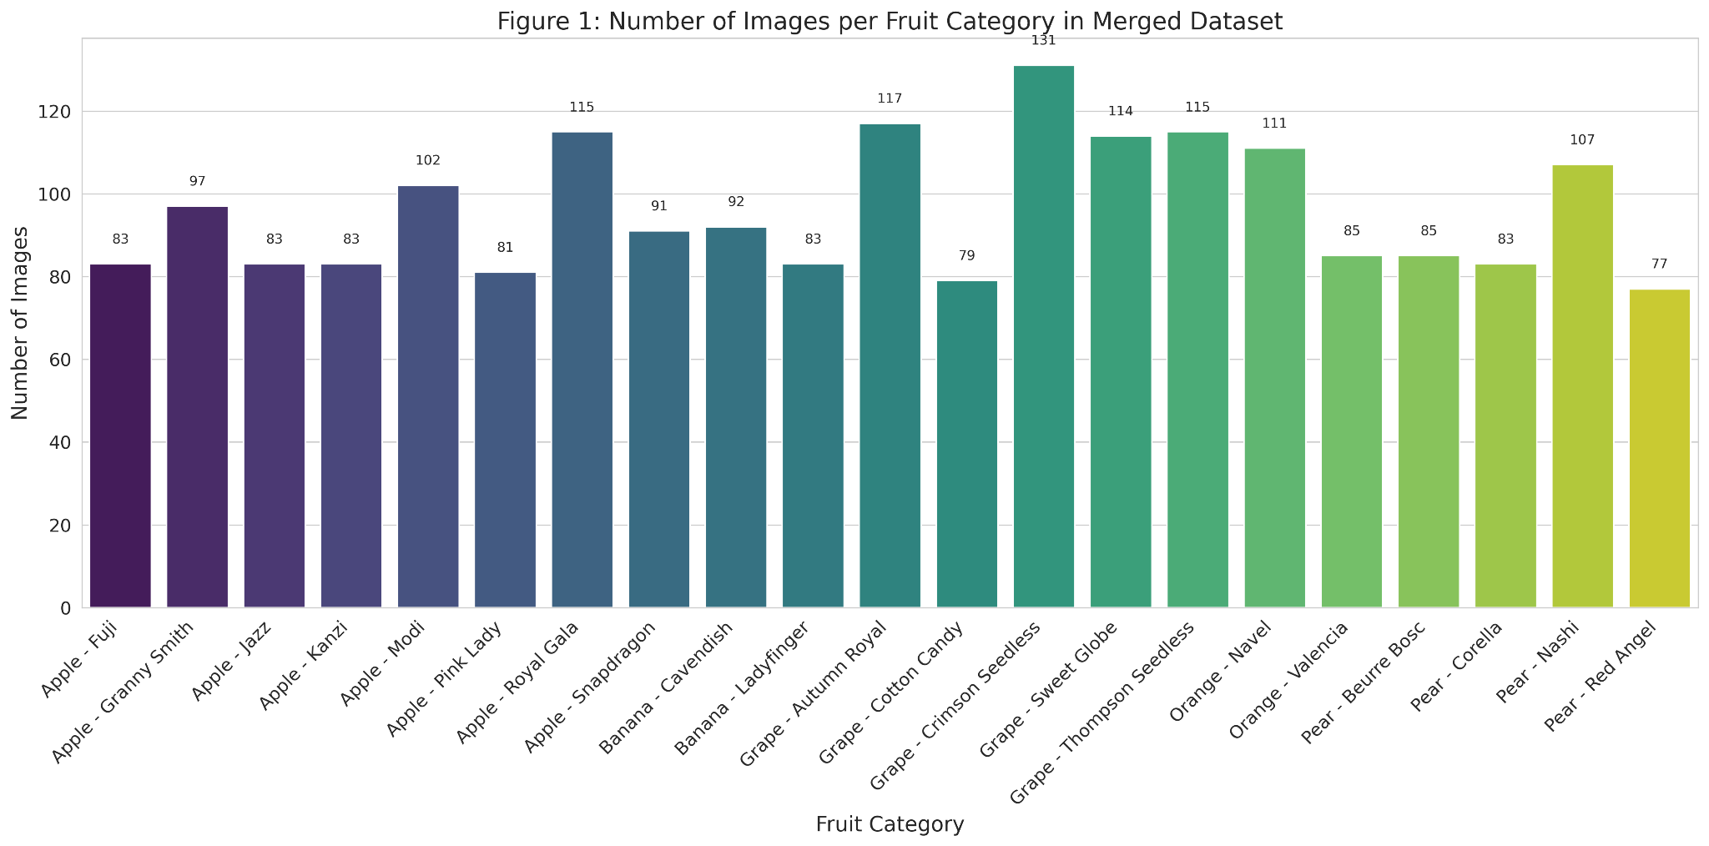

As shown in Figure 1, the distribution of images across fruit categories is reasonably balanced, with most classes containing 80 to 115 images. The top five most represented categories include Grape – Crimson Seedless (131 images), Grape – Autumn Royal (117), Apple – Royal Gala (115), Grape – Thompson Seedless (115), and Grape – Sweet Globe (114). In contrast, the least represented categories include Pear – Red Angel (77), Grape – Cotton Candy (79), and Apple – Pink Lady (81), which may introduce minor data imbalance considerations during training.

2.1.2 Dataset composition by fruit type

For a broader perspective, Figure 3 visualises the dataset distribution aggregated by fruit type. Apple varieties dominate the dataset, comprising 36.5% of total images, followed by Grapes (27.6%), Pears (17.5%), Oranges (9.7%), and Bananas (8.7%). This reflects the team’s collective focus and availability of certain fruit types during the data collection phase.

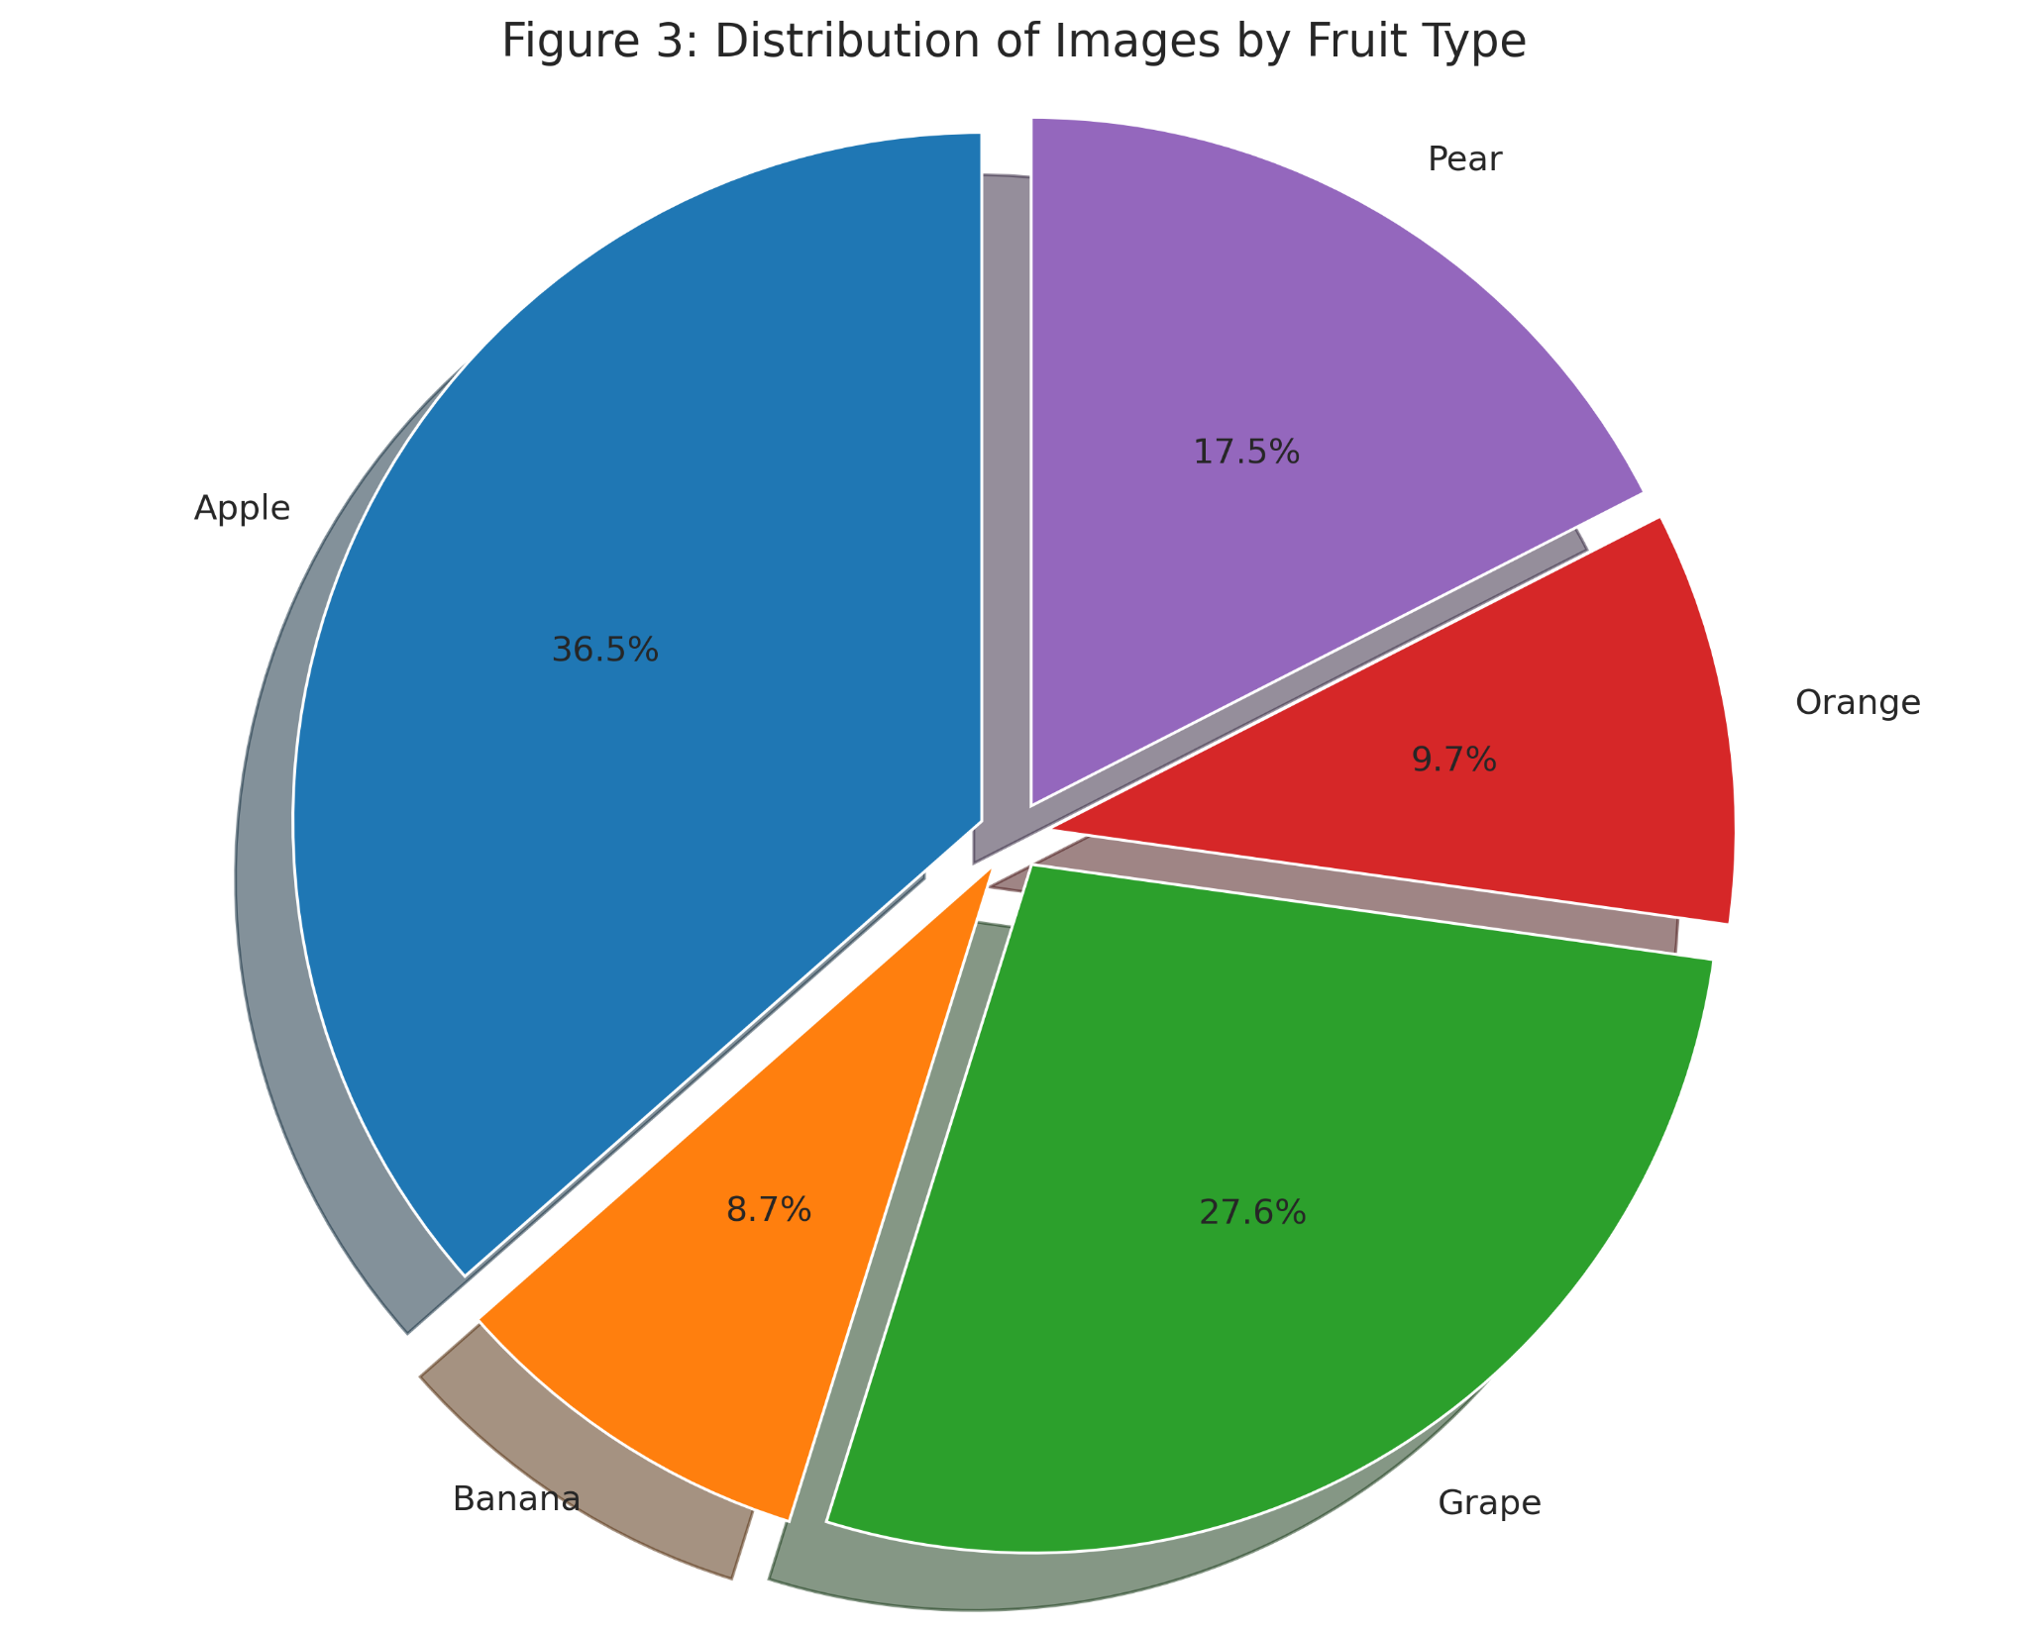

2.1.3 Team contribution and diversity

The merged dataset reflects a collaborative effort. As shown in Figures 4–5, Jasmine contributed nearly half the dataset (48.2%), followed by Taha (18.5%), Gary (17.6%), and Prakhar (15.7%). The team ensured all members contributed to each fruit category, as illustrated by the class-wise heatmap in Figure 7, demonstrating a deliberate effort to achieve consistency across contributors.

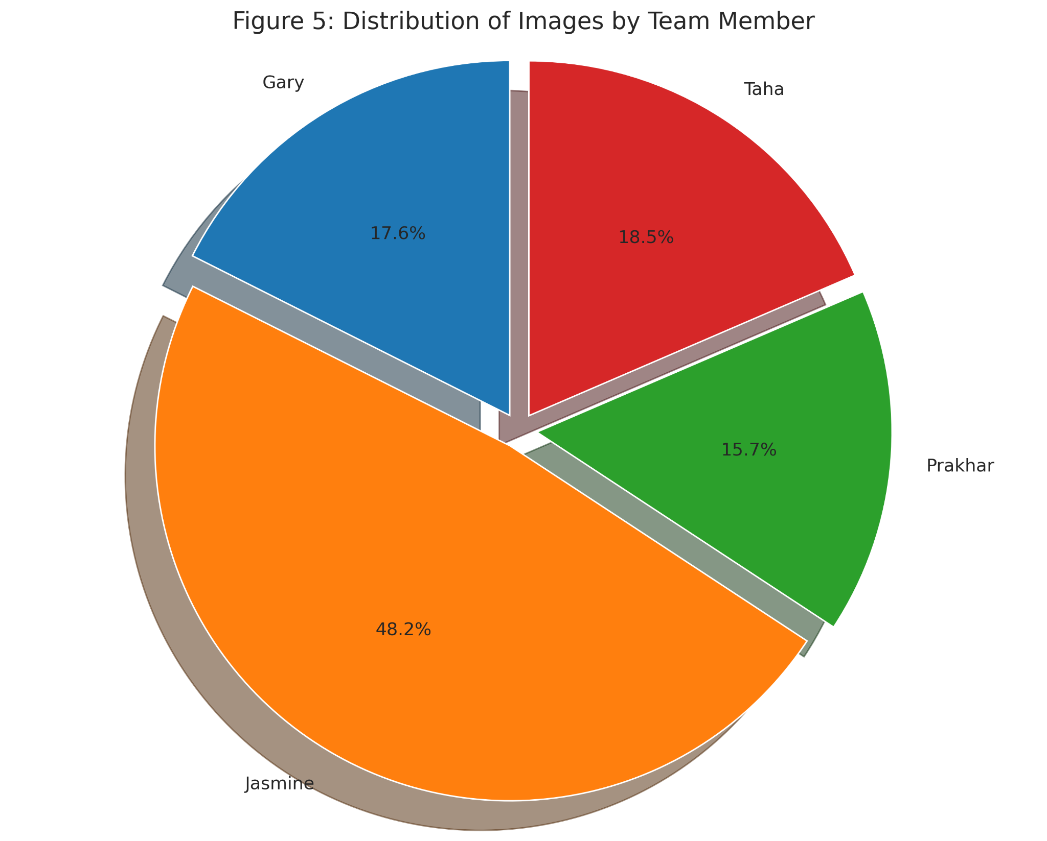
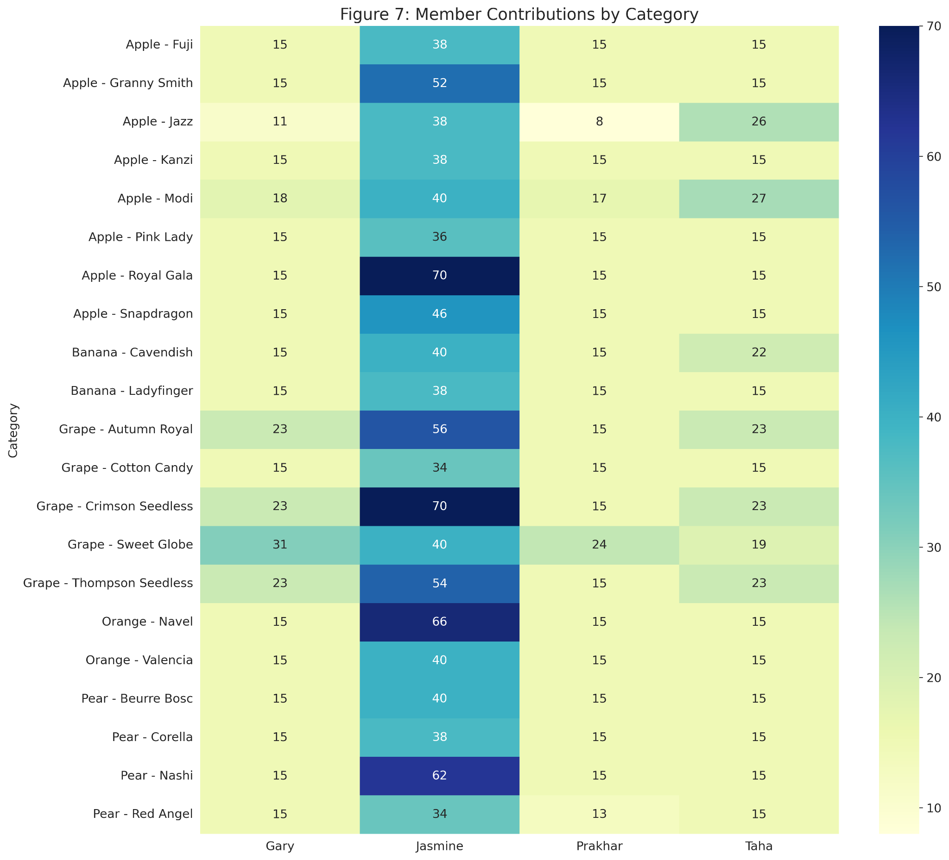

2.1.4 Image format and diversity
To accommodate different devices and environments, team members submitted images in various formats. As seen in Figure 6, JPEG is the most common format (53.4%), followed by JPG (34.4%) and HEIC (11.9%). A small number of PNG files (0.3%) were also included.
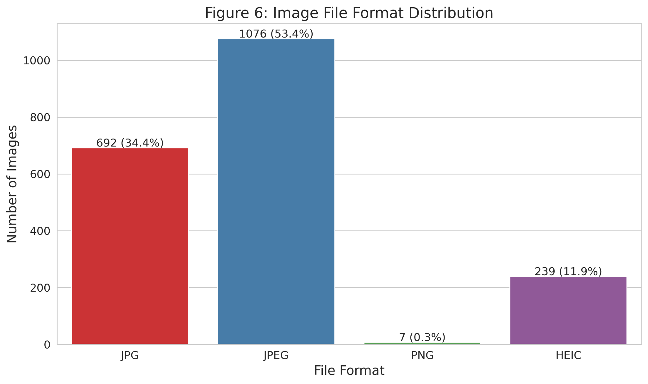
To ensure consistency during model training and avoid compatibility issues, all images were subsequently converted to a standardized JPEG format with unified resolution (224×224 pixels) during the preprocessing phase. This conversion was performed using a custom pipeline that also handled corrupted or truncated images, resized all inputs to match the model requirements, and normalized filenames to include category and contributor metadata.
2.2 Class Selection for Robot Deployment (3 Classes)
For Phase 3 deployment and robot interaction, we selected three visually similar grape varieties from our full dataset: Crimson Seedless, Thompson Seedless, and Autumn Royal. This decision was guided by both strategic and practical considerations.
Firstly, selecting three grape classes allowed us to continue exploring the fine-grained classification challenge, which is one of the core themes of our project. Grapes exhibit high intra-class similarity in terms of size and shape, making them ideal for testing the model's ability to distinguish subtle visual differences under real-world conditions.
Secondly, these three classes were well-represented in our merged dataset (see Figure 1), with Crimson Seedless and Thompson Seedless among the top five most populated categories. This provided sufficient training examples for fine-tuning and reliable evaluation.
Importantly, all three selected classes were also included in each group member’s individual dataset and model development during Phases 1 and 2. Notably, Thompson Seedless was frequently misclassified in earlier evaluations, often confused with other grape types. Its inclusion here provides an opportunity to investigate this confusion further and evaluate whether additional domain-specific fine-tuning using robot-captured images can improve its classification accuracy.
Overall, this selection supports both the project’s technical goals and dataset-driven reasoning, while enabling a focused yet challenging deployment scenario for real-time robotic inference.

3. IMAGE CAPTURE USING ROBOT HARDWARE

3.1 Overview and Hardware Integration
To support our grape classification task, we adapted and extended the ROS2 nodes from Practical Week 8. Our setup involves multiple Python scripts, each with a specific role in capturing images and controlling the robot. Below is a brief overview of the key files involved:

File Name | Purpose | Origin
model.wrapper | Loads our fine-tuned EfficientNet-B0 model for classifying grape types. | Developed by the team
capture_sub.py | Captures a single image frame on user input and saves it for classification. | Adapted from week 08 practical resources
inference.py | Performs inference on captured images and issues movement commands to the robot arm. | Developed by the team

3.1.2 From Continuous to On-Demand Image Capture
In the original Week 8 practical, images were captured continuously from the /depth_cam/rgb/image_raw topic, resulting in redundant storage and little control over image quality. To address this, we modified the capture node (capture_sub.py) to support on-demand image capture.

Instead of saving every incoming frame, the node waits for a user keystroke (pressing Enter). Once triggered, it captures a single, high-quality frame and then resets the flag. This approach not only reduces unnecessary data but also mimics a photographer’s intentional capture, selecting only clear and well-framed images for classification.

3.1.3 Streamlined Terminal Workflow for Environment Stability
Another key improvement involved simplifying the terminal workflow. In Week 8, users were instructed to open a separate terminal after sourcing the workspace to run the image capture node. However, this caused ROS environment variables or overlays to be lost, leading to runtime errors.

To avoid this, we retained all camera operations within the same terminal session. After building with colcon build and sourcing using source install/setup.zsh, we immediately launch the node using: ros2 run capture_topic capture_subscriber. This ensures that all environment variables remain active, allowing the package to be located and executed correctly without errors.

3.1.4 Capturing Images for the Grape Dataset
Our customized image capture setup was used to collect high-quality images of three grape varieties: Crimson Seedless, Thompson Seedless, and Autumn Royal. The robot was mounted on a trolley with the RGB-D camera fixed at chest height. We moved it across various lighting environments, including standard lab lighting, natural daylight near windows, and under LED floodlights, to simulate real-world variation.

Each fruit class was photographed against diverse backgrounds such as:

- The blue lab trolley surface,
- A neutral grey desk,
- A green notebook cover, and
- The original fruit packaging.

We manually adjusted the robot’s position and camera angle to capture different perspectives and occasionally used a handheld flash to bring out surface textures. Every image was captured manually by pressing “Enter”, ensuring focus and framing were ideal. This method prevented blurry or irrelevant images from being stored.

In total, we captured over 50 images per class. After filtering for quality, each class retained at least 45 usable samples, which were then split into training and test datasets.

3.1.5 Integrating Motion Control into Inference
To support precise positioning during image capture, we built on the motion control nodes from Practical Week 09. The original move.py and stop.py nodes allowed simple control using hard-coded velocities or command-line arguments. However, they lacked adaptability and real-time interaction.

In our approach, we integrated motion control directly into the inference.py node. Rather than relying on user input or external scripts, movement is triggered automatically based on classification outcomes. The node publishes Arm gestures using ServoPosition messages.

Each movement is dynamically determined by the predicted grape class, allowing the robot to respond in real-time and eliminating the need for manual intervention.

3.1.6 Multi-Terminal System Operation
For system stability and modularity, we manage the complete workflow across three separate terminal sessions:

- Terminal 1 runs the image capture node.
- Terminal 2 runs the inference node that processes images and triggers robot actions.

This structure ensures each component runs in a properly sourced ROS environment, with clear separation and easier debugging during testing and demonstration.

3.2 Visualisation of Raw Robot-Captured Images

Below are sample images captured by the robot for each of the three selected classes: Grape – Crimson Seedless, Grape – Thompson Seedless, and Grape – Autumn Royal. For each class, five representative examples are shown to illustrate the visual diversity in perspective, lighting conditions, and object positioning within the robot’s workspace.

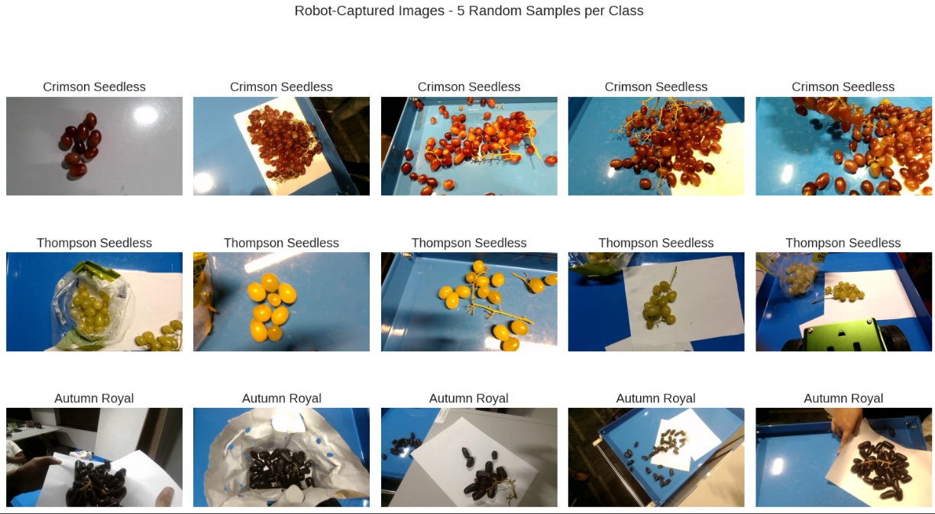

These raw images serve as the input for the subsequent preprocessing pipeline, which includes image resizing to 224x224 pixels, format conversion to JPEG, filename standardization, and metadata tagging. This preprocessing is essential to ensure compatibility with the model architecture (EfficientNet-B0), maintain uniform input dimensions, and enhance dataset integrity by addressing issues such as corrupted files or inconsistent file formats. The final preprocessed images are then used for fine-tuning and evaluation in the robot deployment context.
3.3 Dataset Partitioning Strategy (Robot Images)
After capturing a total of 165 images using the robot's onboard camera, we divided the dataset into 70% for fine-tuning and 30% for testing. This partitioning strategy is commonly adopted in machine learning practice to provide a balance between training efficiency and evaluation reliability (Goodfellow et al., 2016).
In our context, the 30% test set is particularly important, as it allows us to evaluate the model’s ability to generalize unseen images collected directly from our target deployment environment, namely, real-world images captured by the robot. Since this test set consists of our group-captured data, it provides a realistic assessment of the model’s performance in the specific conditions it was designed.
Each of the three selected grape classes was evenly represented in the split, ensuring no class imbalance in the evaluation process. The actual class-wise distribution is shown below:
Class | Total | Fine-TuningSet (≈70%) | Test Set (≈30%)
Crimson Seedless Grape | 57 | 39 (68.4%) | 18 (31.6%)
Thompson Seedless Grape | 53 | 37 (69.8%) | 16 (30.2%)
Autumn Royal Grape | 55 | 38 (69.1%) | 17 (30.9%)
Total | 165 | 114 (69.1%) | 51 (30.9%)
This strategy allows us to fine-tune the model effectively on the robot-specific domain (e.g., lighting, angle, and hardware-induced variation) while preserving the integrity of model evaluation using a held-out test set for each class.

4. MODEL SELECTION AND FINE-TUNING
4.1 Classifier Choice and Rationale
To determine the most suitable classifier for Phase 3 deployment, we evaluated the performance of each team member's models from Phases 1 and 2. Each member independently experimented with different deep learning architectures on the 21-class fine-grained fruit dataset. The group’s final decision was based on a comparative analysis of key performance metrics, including test accuracy, model size, and inference efficiency, alongside considerations of practical deployment constraints.
The summary of each member’s best-performing model and configuration is presented below:
Member | Explored Models | Best Model & Configuration
Jasmine | DenseNet-201, EfficientNet-B0 | EfficientNet-B0  • Partial fine-tuning, no data augmentation  • 99.28% test accuracy  • Inference time: 3.09 ms/image  • Model size: 15.68 MB
Prakhar | ResNet50, ViT | ResNet-50  • 70-15-15 data split  • Batch size: 32  • Partial fine-tuning (final ResNet-50 layer unfrozen)  • StepLR learning rate schedule  • 15 epochs  • Moderate data augmentation: random resized crop, horizontal flip, colour jitter, ImageNet normalization  • 95.83% test accuracy
Taha | RestNet50, VGG-16 | ResNet-50  • 60-10-30 data split  • Batch size: 8  • Partial fine-tuning (layer4 and layer3 unfrozen)  • OneCycleLR scheduler  • 15 epochs  • Extensive data augmentation: resize, horizontal flip, rotation, perspective, affine, color jitter, grayscale, random erasing, normalization  • 75.22% test accuracy
Gary | EfficientNet-B0, EfficientNet-B4 | EfficientNet-B4  • 60-10-30 data split  • Batch size: 6  • Partial fine-tuning (final block unfrozen)  • LambdaLR scheduler with exponential decay after epoch 8  • 25 epochs  • Moderate data augmentation: resize to 448×448, horizontal flip, rotation up to 26°, color jitter (brightness=0.11, contrast=0.12, saturation=0.09, hue=0.08), ImageNet normalization  • 75.44% test accuracy

Across all experiments, EfficientNet-B0 emerged as the most effective model for our task. With only 5.3 million parameters and 0.39 billion FLOPs, EfficientNet-B0 achieves a strong balance between computational efficiency and accuracy, making it highly suitable for deployment in resource-constrained robotic systems.
EfficientNet-B0’s success can be attributed to its compound scaling design, which optimally balances depth, width, and resolution for robust feature learning. Additionally, its support for transfer learning via pre-trained ImageNet weights enables strong generalization, even with limited domain-specific data, as in our case with robot-captured images.
Notably, the relevance of EfficientNet-B0 for fruit classification tasks has been demonstrated in prior research. Duong et al. (2020) reported 99.97% accuracy using EfficientNet-B0 on the Fruits-360 dataset, outperforming conventional CNN architectures. This strong empirical foundation, coupled with our own Phase 2 results, where Jasmine’s EfficientNet-B0 model achieved the highest test accuracy of 99.28%, reinforced our decision to adopt EfficientNet-B0 as the core model for Phase 3 deployment.
Furthermore, given the specific focus of our project on fruit classification, EfficientNet-B0’s proven effectiveness on fruit datasets aligns directly with our objectives. Its capacity to generalize across fine-grained fruit classes, particularly grapes with subtle visual differences, makes it the most appropriate choice for real-time deployment in our robotic system.
4.2 Fine-Tuning on Phase 2 Data (All Classes, All Members Dataset)
Following the fine-tuning of EfficientNet-B0 on the full merged dataset containing all 21 fruit classes, we conducted a focused evaluation on the robot-captured test set to assess the model’s generalization capability in real-world deployment conditions. The test set consisted of three grape varieties: Grape – Crimson Seedless, Grape – Thompson Seedless, and Grape – Autumn Royal.

The evaluation results reveal mixed outcomes. The overall accuracy across all three classes was 0.51, indicating moderate transferability of the model from the general fruit dataset to the robot-specific data domain. However, per-class performance varied significantly. As shown in Figure 8, the model achieved perfect accuracy (1.00) on Grape – Autumn Royal, suggesting strong generalization for this class. In contrast, the model performed moderately on Grape – Crimson Seedless with an accuracy of 0.50, while it completely failed to classify Grape – Thompson Seedless correctly, resulting in an accuracy of 0.00.

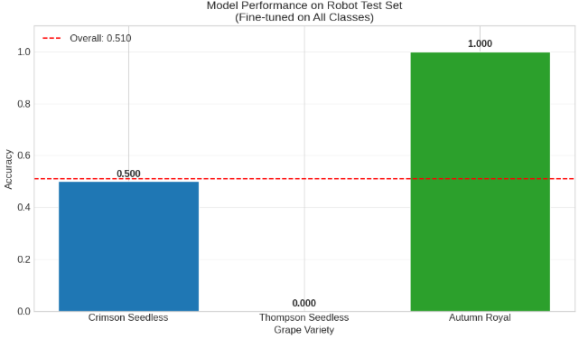
Figure 8: Model performance on robot test set across three grape varieties.
To better understand the misclassifications, a confusion matrix was generated, as shown in Figure 9. The matrix indicates that Thompson Seedless samples were consistently misclassified as other grape varieties such as Cotton Candy and Sweet Globe, reinforcing the challenges of fine-grained fruit classification under real-world variations. In contrast, the model correctly classified most Autumn Royal samples, while Crimson Seedless exhibited a moderate degree of confusion.

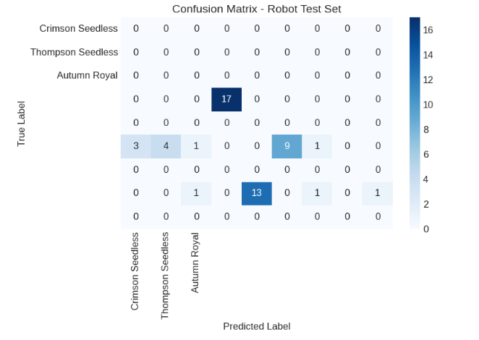
Figure 9: Confusion matrix for model predictions on robot test set (three grape varieties).
These results highlight the limitations of relying solely on general fruit datasets without domain-specific fine-tuning. The model's inability to distinguish Thompson Seedless grapes underscores the necessity of further adaptation to the visual nuances introduced by the robot’s camera system and capture environment. This evaluation serves as a critical baseline, informing subsequent robot-specific fine-tuning efforts aimed at enhancing model robustness for real-time deployment.
4.3 Fine-Tuning on Phase 3 Robot Data (3 Classes Only)
Now, instead of fine-tuning the EfficientNet-B0 model on all of our data, we fine-tuned it specifically on the same three classes we would test on - i.e. Grape – Crimson Seedless, Grape – Thompson Seedless, and Grape – Autumn Royal. Our objective was to compare the model’s performance when fine-tuned on the three selected classes against the model fine-tuned on all our 21 classes. Both the test set and the set of images for fine-tuning were captured from the robot’s camera. The fine-tune set contains 114 images, out of which 96 images were used for training, 18 for validation, and 51 total images were reserved for testing.
On evaluation, this model showcased significantly better performance, with an accuracy of 98.04% - i.e. 50 correct classifications out of 51. Unlike before, every Thompson Seedless image was classified correctly. The only misclassification belonged to the class “Grape - Crimson Seedless”, which is dark red in color, being predicted as “Grape - Autumn Royal”, which is black. This was most likely caused due to a glare present in the actual image.
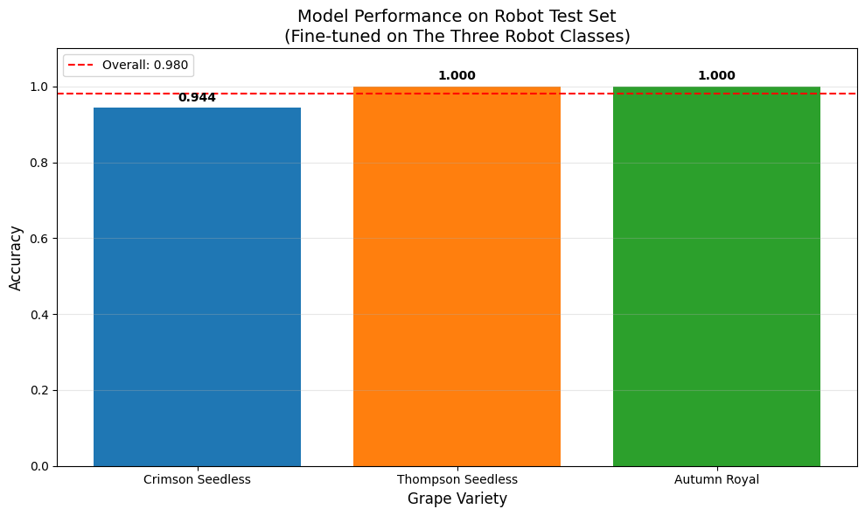
Figure 10: New model’s performance on robot test set across three grape varieties.
Overall, after fine-tuning EfficientNet-B0 on the same three classes as the test set, instead of fine-tuning on the entire dataset, we were able to improve the model by a remarkable 92.31%. This reinforces the hypothesis that when attempting fine-grained classification on classes that are highly similar to each other, fine-tuning the model on their domain exhibits significantly higher generalizability.

5. DEPLOYMENT AND ROBOT BEHAVIOR
5.1 Deployment Setup
In general, we use capture_sub.py to capture images of the actual fruit locations. Then, inference.py processes these images to detect and classify the fruits. The inference script utilises our EfficientNet-B0 model (implemented in the model.wrapper file). Based on the classification results, if the confidence score is above 0.75, the robot performs the corresponding arm movements to interact with the detected fruit automatically.
This program is built using several important libraries that work together to help a robot see, understand, and act. The system runs on ROS2 (Robot Operating System 2), which is a platform used to build robot software. It helps different parts of the robot talk to each other. In this case, the robot listens to camera images and sends commands to move its wheels and arm. The library rclpy (ROS CLIENT) is the Python interface for ROS2, and it is used to create the robot node and manage publishers and subscribers.
5.1.1 To control the robot
To control the robot's base (wheels), the program uses messages from the geometry_msgs.msg library, especially the Twist message. This message lets the robot move forward, backward, or turn. For the robot's arm, the program uses custom messages from ros_robot_controller_msgs.msg, which include ServosPosition and ServoPosition. These messages allow the robot to move parts of its arm by sending a position and duration.
5.1.2 How robots detect objects and react to them
The robot uses its camera to understand the world. The sensor_msgs.msg.Image message type is used to receive images from the robot’s camera. These images come in a ROS-specific format, so the program uses CvBridge to convert them into a format that the computer vision libraries can understand. To process the images and detect the type of grape, the program uses PyTorch, a deep learning framework. It loads a fine-tuned EfficientNet-B0 model that has been trained to recognise three different grape types. The image is preprocessed using tools from torchvision, and the model makes a prediction. Based on the result, the robot either moves or uses its arm, depending on what it sees. All this is done using threading to let the user press Enter to start or stop the robot’s actions at any time.
To trigger the robot's camera, the robot uses it to look at the grapes in front of it and decide what action to take. This is handled by the image_callback function in the script. The camera continuously sends images to the robot, and this function runs every time a new image is received. The image is first converted from the ROS format to a standard image format using CvBridge. Then, the image is transformed into a PyTorch tensor and passed into a pre-trained deep learning model called EfficientNet-B0. This model was trained to recognize three types of grapes. The model analyzes the image and returns a prediction with a confidence score. If the confidence is higher than a set threshold (75%), the robot prepares to take action. Based on the detected grape type, the robot may move its robotic arm differently automatically.
5.2 Action Mapping Design
In the implementation of the robot's inference system, each grape type detected by the EfficientNet-B0 model triggers a unique movement to ensure the robot responds in an observable and distinguishable way.
Our robotic setup uses servo motors to control the arm’s movement based on fruit classification results from the inference.py script.
- Servo ID 1 controls the circular base, allowing horizontal rotation (left-right movement);
- Servo ID 2 controls the base joint, meant to move the arm vertically (up-down) from the base;
- Servo ID 3 controls the elbow joint, designed to vertically extend or curl the arm.
- Servo ID 4 controls the hinge that holds both the claw and the camera, allowing vertical movement.
- Servo ID 5 controls the horizontal position of the claw; and
- Servo ID 10 opens or closes the claw.
When a fruit is detected and classified as Class 0 (Autumn Royal), the robot sets servo ID 1 to 900 and servo ID 2 to 650 and servo ID 4 to 500, resulting in a low and extended arm posture that makes it move left. For Class 1 (Crimson Seedless), both servo IDs 1, 2, 3 and 4 are set to 500, bringing the arm into a centred and balanced position. In the case of Class 2 (Thompson Seedless), the arm moves into a more extended posture by setting servo ID 1 to 100 and ID 2 to 650 and ID 4 to 500, making the arm move right. These specific angle values are carefully chosen to produce distinct arm movements that visually represent the robot’s recognition of different fruit classes.
The robot only performs these arm gestures and does not include grasping or picking functionality. Additionally, we deliberately avoid allowing the robot to move forward or backward during classification. This decision is made to prevent accidental collisions or fruit damage in case the robot fails to stop in time. By limiting its actions to controlled arm movements, the robot safely demonstrates the classification outcome without physical risks.
These motions are summarized in the table below:
Class | Grape Type | Arm Motion (Servo ID: Position) | Purpose
0 | Autumn Royal | 1: 900 (left)  2: 650 (low)  3: 50 (curled)  4: 500 (tilted down)  10: 500 (half-open) | Low leftward reach
1 | Crimson Seedless | 1: 500 (middle)  2: 500 (middle)  3: 500 (middle)  4: 500 (middle)  10: 100 (open) | Straight upward extension (neutral)
2 | Thompson Seedless | 1: 100 (right)  2. 650 (right)  3: 50 (curled)  4: 500 (tilted down)  10: 500 (half-open) | Low rightward reach

6. DISCUSSION AND ANALYSIS

6.1 Adaptability to Hardware-Captured Data

Our results demonstrate that the fine-tuned EfficientNet-B0 model exhibits strong adaptability when deployed on hardware-captured images, particularly for the selected grape classes. The model achieved a final test accuracy of 98.04% after domain-specific fine-tuning on robot-captured images, with successful classification of all Thompson Seedless and Autumn Royal samples, and a single misclassification for Crimson Seedless due to glare-induced visual artifacts. This improvement from an initial 51% accuracy when using the model trained on the general 21-class dataset highlights the importance of domain-specific fine-tuning when adapting a computer vision system for deployment in a real-world robotic context.

However, this adaptability was influenced by several practical factors during image capture and deployment. We captured images by manually moving the robot closer to the objects, holding it by hand, and carefully framing shots to ensure quality. This method, while effective for data acquisition, did not fully reflect the fixed-camera conditions during real-time deployment. During deployment, we discovered that optimal performance requires the robot’s camera to remain in a stable position, while the object (the fruit) is placed within its view range at an appropriate distance. This discrepancy between data capture conditions and deployment setup highlights a critical lesson: ensuring consistency between training and deployment environments is essential for robust performance.

Furthermore, we observed hardware-induced variability among the robots, even though they were of the same model. Differences in camera sensor quality, resolution, and exposure handling affected image quality, introducing slight domain shifts that could influence inference accuracy. Such variability underscores the need for comprehensive testing across multiple robot units and for building more generalizable models that can handle hardware inconsistencies in real-world deployments.

6.2 Successes and Limitations
One of the key successes of our Phase 3 deployment is the achievement of real-time image classification and action execution. The robot accurately recognized the three selected grape classes and performed distinct, pre-defined arm movements in response, demonstrating the system’s capacity to translate visual perception into physical actions. The final demonstration video confirms that the system can effectively integrate computer vision and robotics for task-specific automation, even in a constrained hardware setting.
Nonetheless, several limitations remain. First, the Thompson Seedless grape class consistently presented challenges, with lower confidence scores compared to other classes, even after fine-tuning. This highlights the inherent difficulty of distinguishing fine-grained classes with high visual similarity. A practical improvement would be to collect a larger and more diverse set of Thompson Seedless images under varied lighting conditions, angles, and backgrounds to enhance model robustness. Additionally, future iterations could explore data augmentation techniques tailored to domain-specific challenges, such as simulating glare, blur, or occlusion, to improve generalisation.
Technical limitations during deployment also hindered progress. A key challenge was the iterative development process with ROS 2. Each time a bug was identified and a fix was applied, we were required to rebuild the entire ROS environment, restart the camera node, and recompile packages. This cycle became time-consuming and frustrating, particularly given the robot’s limited battery life, which often depleted before sufficient testing could be completed. The inefficiency of this workflow not only slowed development but also disrupted focus and momentum.
Additionally, the limited battery life of the robots constrained testing duration, requiring frequent recharging and interrupting the workflow. Variations in camera sensor quality across different robots also introduced inconsistencies in image quality, potentially affecting inference results. Addressing these issues in future work would involve standardising hardware calibration, improving power management strategies, and incorporating tools for real-time error detection and handling.
6.3 Reflection and Future of Work
This phase of the project underscored the complexity of transitioning from controlled datasets to real-world robotic deployment. We learned that model fine-tuning must be accompanied by careful consideration of the operational environment, hardware limitations, and data acquisition methods. For future work, we propose expanding the dataset to include more diverse scenarios, automating data capture directly from the robot’s fixed camera in deployment conditions, and exploring lightweight model architectures or on-device optimizations to improve inference speed and energy efficiency. Furthermore, integrating feedback mechanisms such as adaptive thresholding or online learning could enhance system robustness and adaptability in dynamic real-world settings.
Additionally, future projects would benefit from exploring more efficient debugging strategies, such as modular testing without requiring full environment rebuilds, containerization for isolated development environments, and more robust error-handling mechanisms to minimise downtime during development. These improvements could streamline the workflow, reduce frustration during iterative testing, and make the system more maintainable for larger-scale deployments.

7. CONCLUSION
This phase demonstrated the successful deployment and monitoring of our fine-grained fruit classification system in a robotic context. By fine-tuning the EfficientNet-B0 model on hardware-captured images of three selected grape varieties, we achieved high classification accuracy (98.04%) and enabled the robot to perform distinct, pre-defined actions in response to visual inputs. The system's real-time integration of image classification and robot movement validates its practical feasibility.
However, our work also highlighted several challenges, including hardware inconsistencies across robot units, limited battery life, inefficient debugging, i.e. needing a full rebuild each time we make a change, and the need for more comprehensive data collection, particularly for visually similar classes such as Thompson Seedless grapes. Addressing these limitations is essential for enhancing model robustness and deployment reliability.
This phase reinforced the importance of domain-specific fine-tuning and careful consideration of the hardware-software interface in applied computer vision systems. Future work should focus on expanding the dataset to cover a wider range of deployment scenarios, optimising system efficiency, modular testing and incorporating adaptive mechanisms to improve long-term performance in dynamic real-world environments.

REFERENCES:
Duong, L. T., Nguyen, P. T., Di Sipio, C., & Di Ruscio, D. (2020). Automated fruit recognition using EfficientNet and MixNet. Computers and Electronics in Agriculture, 171, 105326. https://doi.org/10.1016/j.compag.2020.105326
Macquarie University. (2025). Practical resources for COMP8430: Advanced computer vision and action (Weeks 4, 8–9). Unpublished course materials.

